MATH 107 6383, Fall, 2014
UMUC
Midterm Exam

Show your work on all the problems. Submit your completed exam in the
assignment folder.

Total Points: 100
Due: September 21

- a. Find the midpoint of the segment with endpoints (5, –2) and (7, 4).

- The point (4, –1) is on a circle with center (7, 3). Find the length of radius of the circle.

2. Simplify: $\frac{−\text{32}{\text{ x}}^{\text{-4}}y^{3}}{4x^{\text{-5}}{\text{ y}}^{8}}$

- a. Find the slope-intercept equation for a line with slope 5 and which
passes through the point (1, –2).

b. Find the slope of the line through the points (8, 1) and (7, 3).

4. a. Solve: $\sqrt{2\text{ - 7x }} =\text{ 2}$

b. Solve $\sqrt{\sqrt{\sqrt{x}}}=2$

5. Find the domain of the functions:

a. $f(x)=\frac{3}{x}+\text{ 2}$

b. $f(x)=\frac{1}{x^{2}\text{ - 6x }+\text{ 5}}$

6. a. For the graph of the function f (x) = x² – 5x + 6, find the vertex and the axis of symmetry.

b. One number is 2 more than another. The product of the numbers is 35.
Find the numbers.

7. A salesperson earns a base salary of $2,000 per month and a commission
of 5% on the amount of sales made. If the salesperson has a paycheck of
$3,006 for one month, what was the amount of sales for the month?

8. a. For x values in what interval (s) is the function increasing?

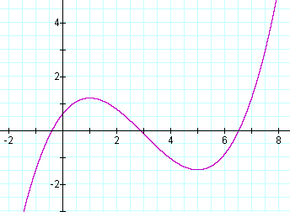

b. Determine whether the graph of y = 3 + x² is symmetric with respect to
x-axis, y-axis, or the origin.

9. a. Given f (x) = 4/x² and g(x) = 3 – 2x, find the composite function
(f o g)(x) and simplify.

b. Write the equation for a function that has a graph with the given
properties.

The shape of y = |x| but stretched vertically by a factor of 2 and shifted right 3 units.

10. a. Solve for n: 2(n - 1) = 3(n + 5)

b. Find the zero of the function f(x) = 8 – 2x

